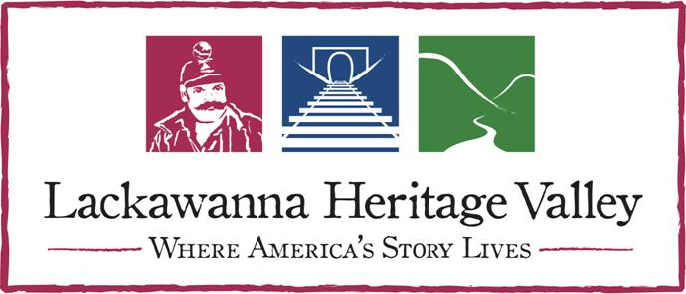 |  |  |  |  |  | Lackawanna Heritage Valley  National and State Heritage Area  213 Railroad Avenue  Scranton, PA 18505  570-963-6730

Ambassadors in Action Volunteer Registration
The Lackawanna Heritage Valley National and State Heritage Area (LHV) invites you to join Ambassadors in Action! Ambassadors in Action is a great way to use your talents, to develop skills, to meet new people, and to help the Heritage Valley accomplish its goals. Your support is invaluable!
Please complete and submit the following form to LHV so that we can get you started volunteering right away! To learn more about LHV and its programs, please visit www.LHVA.org.
Contact Information |  |  |  |  | Please print clearly.
Name
Organization |  |  |  |  |  |  | Title
Address |  |  |  |  |  |  | Phone
City / State / Zip |  |  |  |  |  |  | Emergency Contact
Email |  |  |  |  |  |  | Phone

Agreement and Signature
Please read all of the information carefully and sign below. Your signature signifies that you have read and agree with the following statements pertaining to your participation in Ambassadors in Action:
- I understand that I am a volunteer and may terminate my association with the Lackawanna Heritage Valley (LHV) at any time.
- I agree to behave in conformity with the rules and regulations of Ambassadors in Action. Unacceptable or illegal conduct will result in dismissal from the Ambassadors in Action volunteer program.
- I am aware that volunteers may be photographed for educational, archival, or public relations purposes. I give my consent that photographs of the participant may be published the LHV.
- Since I agree to participate in all activities on a voluntary basis, I release LHV, Lackawanna Heritage Valley Authority (LHVA, and other partnering entities for this event from any liability for injury, illness or disease sustained during participation in activities related to the Ambassadors in Action program.
Signature |  |  |  |  | Date
Date of Birth |  |  |  |  | Age
If you are under 18, this section MUST be completed:
Name of Parent/Guardian |  |  |  |  |  | Relationship
Signature of Parent/Guardian

For More Information
Contact: Volunteer Coordinator John Morrow at volunteer@lhva.org or (570) 963-6730

Please Return this Form to:
Ambassadors in Action c/o LHV
213 Railroad Avenue, Scranton, PA 18505
Fax: (570) 963-6732

Thank You!

